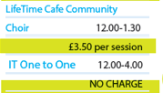

**Correct as of 27/04/2017**

**PLEASE NOTE THESE PRICES WILL TAKE EFFECT AS OF MONDAY 3RD APRIL**

