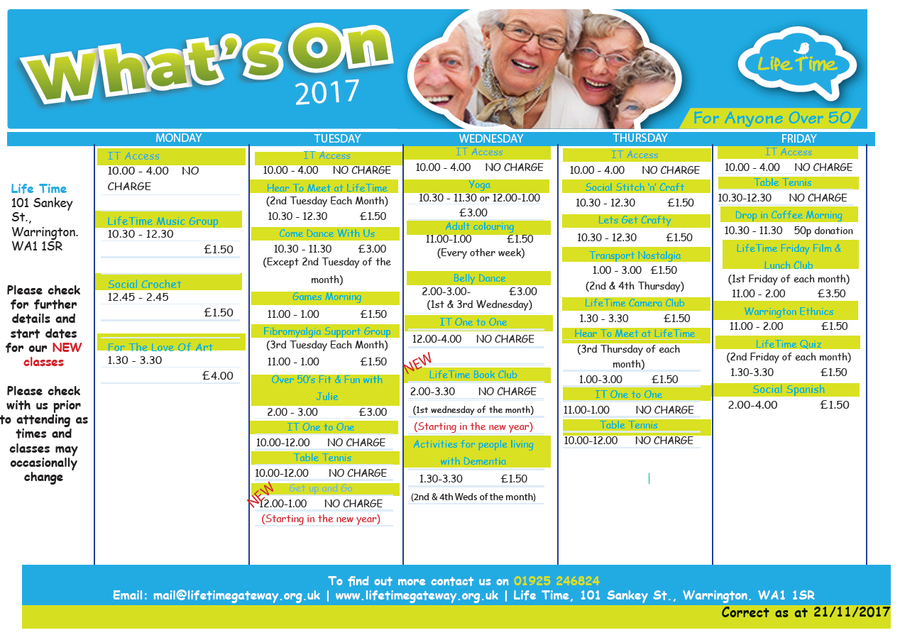

1.00-2.00

**Correct as of 17/01/201818**

**2018**

12.30-1.30

(2nd Wednesday each month)

£1.50

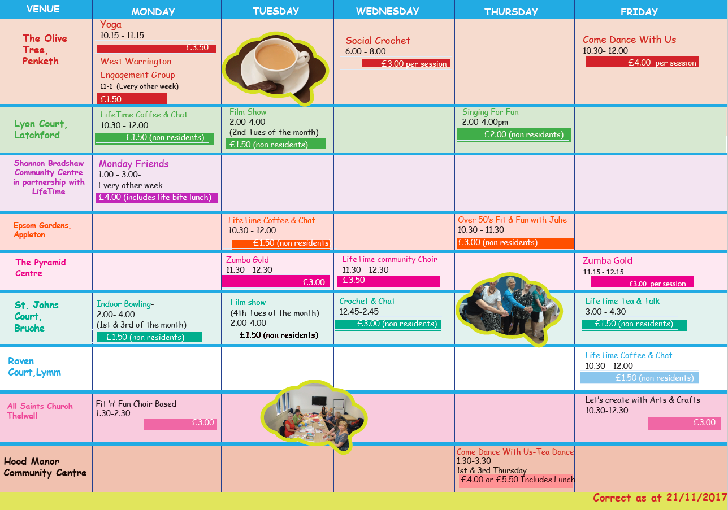

**Correct as of 17/01/201818**

12.00-1.30