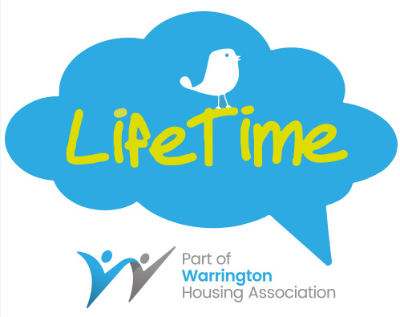

**Cupcake Day**

Do you like being creative or fancy taking part in our friendly Cupcake competition?

All you need to do is either bake or buy cupcakes and design it however you want. There will be a prize for the most creative designed cupcake.

If decorating is not your thing, still come along and buy a cupcake to support the Alzheimer’s Society.

**£1 entry fee for competition**

**£1 per guess on games**

**50p per cake**

**All Proceeds will go to Alzheimer’s Society**

**Thursday 14th June**

**11am-1pm**

**At**

**LifeTime, 101 Sankey Street, WA1 1SR**

For more information contact us on 01925 246824 or mail@lifetimegateway.org.uk