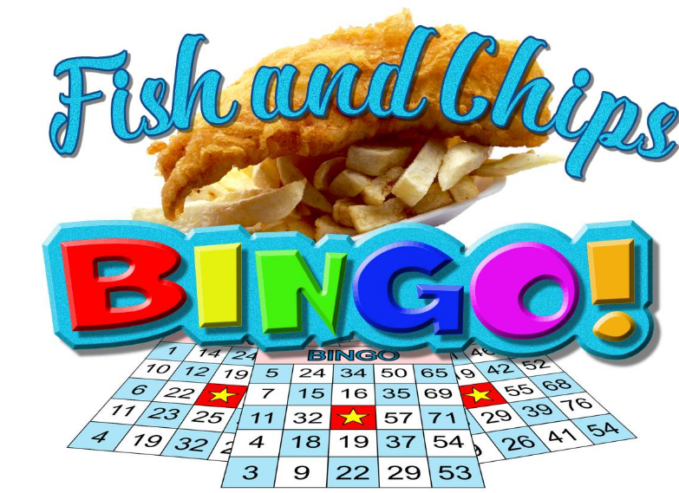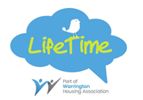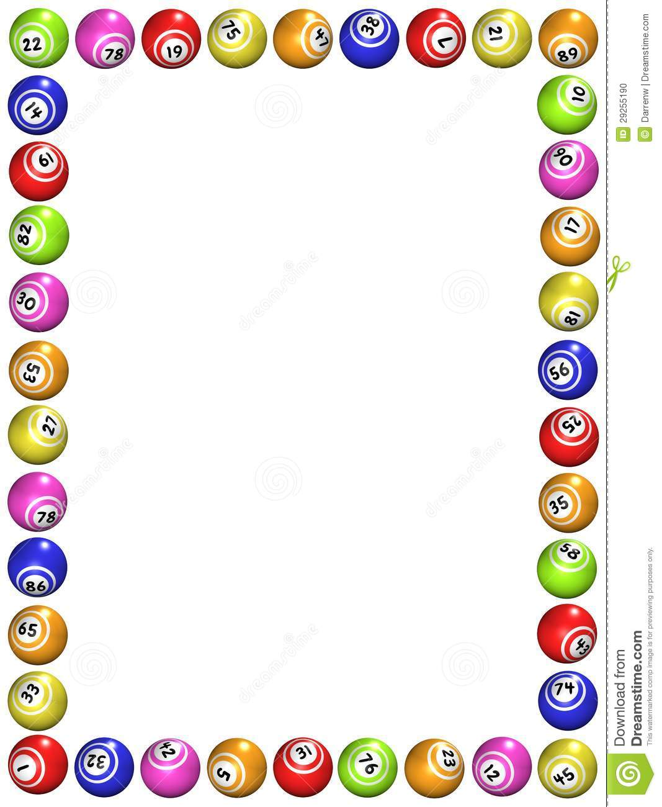

**Starting Friday 28th September**

**12.30-2.30pm**

Join us for a fish and chip lunch followed by an optional cash prize Bingo.

**£4.50 (Fish & Chips with Tea/Coffee)**

**Optional extra- £1 per game of Bingo**

**Please book and pay by Monday 24th September**

**Back by popular demand**